St. Francis Xavier Catholic Church
Parish School of Religion
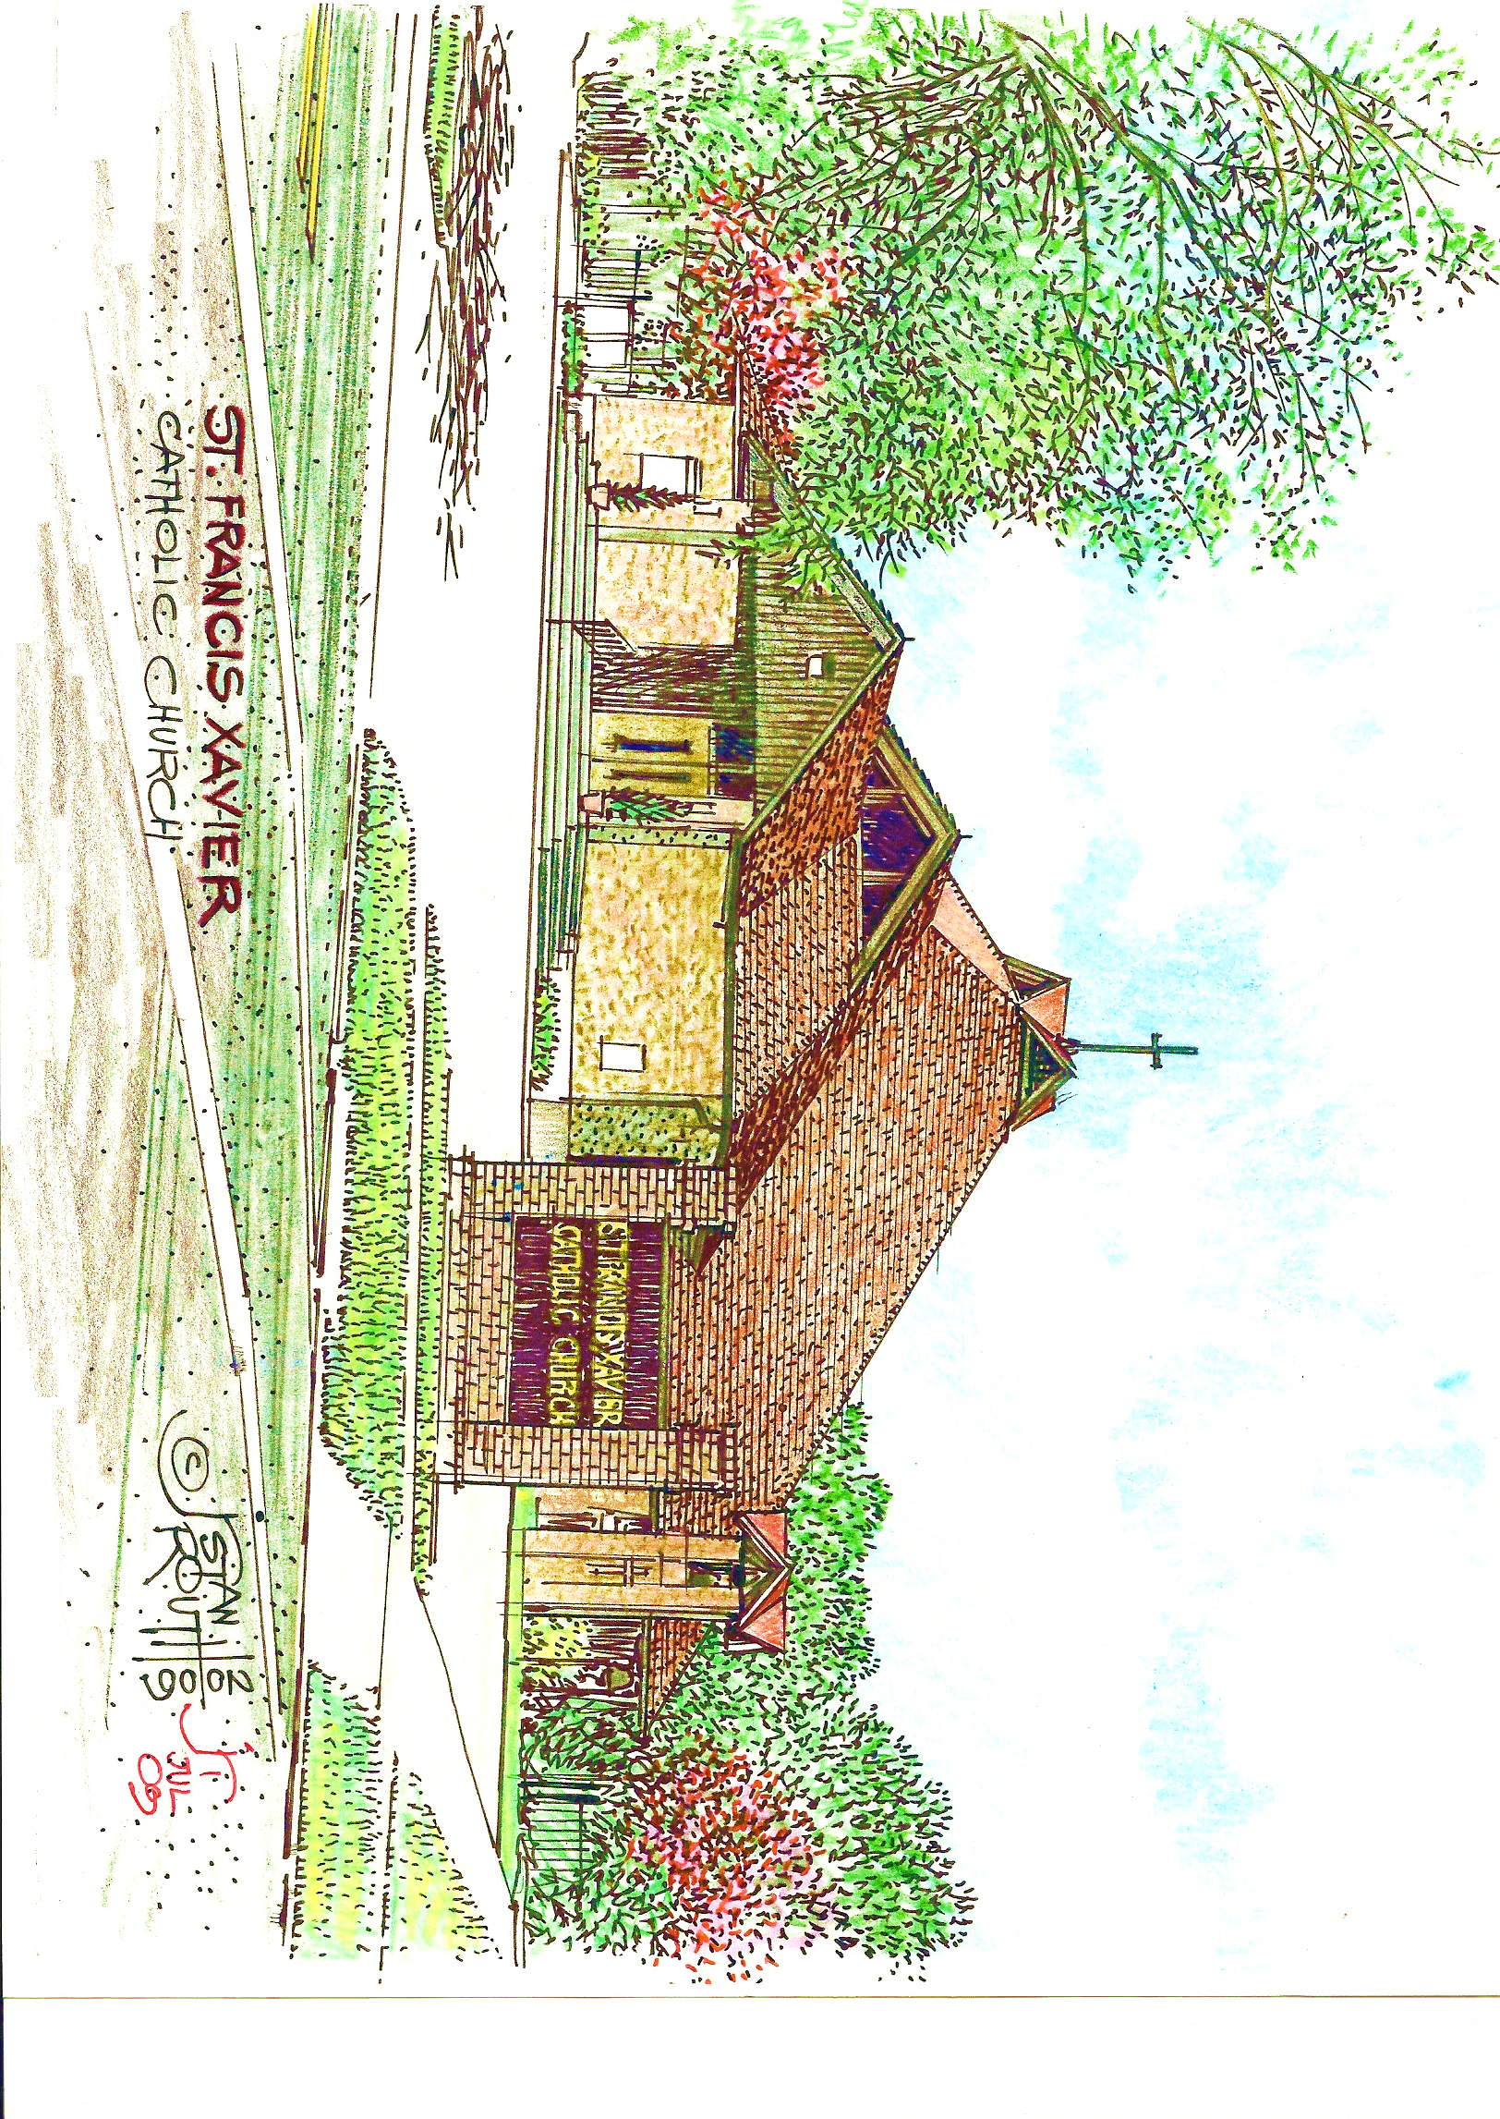
2020/2021

Very Rev. Edward J. Chiffriller, SSJ
Pastor
John A. Young, DRE
Gaylynne Mack, CRE

Notice: Coved – 19 has changed the way we live our lives. Our daily routines, schedules, and appointments have been altered and/or Covet – 19 restrictions may apply. The way we conduct classes and meetings, celebrate Mass, and the Sacraments are not withstanding. One condition that has not changed that we can rest assured of is that through our Father God, His Son Jesus Christ and His Holy Spirit, all who believe in Him will be protected for He is our strength and our shield, our protector and healer.

Most of our policies and many of our schedules remain intact. However, for our health and safety, St. Francis Xavier will adhere to Covet – 19 Safety Guidelines as offered and/or mandated by the medical community for our Federal, State, and Local Governments, and at the directions of the Diocese of Baton Rouge and our Pastor, Very Reverend Edward J. Chiffriller, SSJ.

Parish Policies
For
Religious Education

St. Francis Xavier Parish is committed to fostering high quality religious education for all segments of the parish community. In striving to provide a total program of religious education, the parish seeks to guide parishioners to affirm the call of Jesus, to grow in faith and make a sincere commitment to Him. To provide its parishioners with a better understanding of available programs for participants, the following policies are set forth. These policies seek to conform to present Church policies concerning religious education and sacramental preparation.

Parents are the first and foremost catechist of their children. They catechize informally, but powerfully by example and instruction. They communicate values and attitudes by showing love for Christ, His Church and for each other. They reverently receive the Eucharist and live in its spirit, and by fostering justice and love in all their relationships. Their active involvement in the parish, their readiness to seek opportunities to serve others, and their practice of frequent and spontaneous prayer make their professions of faith meaningful. Parents nurture faith in their children by showing the richness and beauty of a lived faith. Parents should frequently be reminded of their obligation to see to it that their children participate in catechetical programs sponsored by the Church.

School of Religious Education
Policies

- All students must be registered on dates assigned for registration. The registration fee should be paid at the time of registration. Birth and Baptism certificates are required.

- Students should be in class on time. Classes are held every Sunday of every month, 10:00 am – 10:45am except for the alternated dates listed in the Parish School of Religion (PSR) yearly calendar, or when announced at Mass or during class.

- Attendance to all classes is required. All students are allowed 2 absences per semester. A note explaining the reason for the absence is required. Students with excessive absences must repeat the class.

- Excessive tardiness may also cause the student to have to repeat the class the following year.

- Students will be assessed periodically and at the end of the year to determine the student’s level of knowledge.

- There will be a procedure for students who continually disturb the teaching process:

a. If a student disturbs the teaching process on any two occasions, a phone call will notify the parents or guardians.
b. When a student disturbs the process for a third time, the parent or guardians and student will be asked to appear before the DRE and their teacher. The student will remain out of class until he/she appears before the committee. Written documentation of the disturbances will be presented at the meeting.

- Parents of students, who for any reason are catechizing at home, will be required to have and interview with the Director of Religious Education (DRE) covering materials in the religious education textbook and or in Church/Christian Doctrine to determine promotion to the next class level in the religious education program. Receptions of Sacraments are subject to approval of the Pastor.

- If a student stays out of religion class for a whole year or longer, he/she will be placed at the class level where their religious program was stopped.

- Dress Code: Religion classes are held to educate the student in religious matters. Students should come to class suitably dressed; high school students may not attend classes in shorts.
- Students will not be allowed to bring food, drink, gum or snacks into the classrooms or buildings. Snacks brought before class must be finished before classes start.

- Student will not be allowed to leave the grounds once he/she has arrived for religious classes.

- The unapproved usage of cell phones and other electronic devices are not allowed and will be confiscated until classes are over. Failure to relinquish electronic devices will result in suspension.

- Guests are only permitted with prior approval of the DRE.
Amendments to Parish Policies

- It is mandatory that teachers, staff, and volunteers take the Child Protection Workshop given by the Diocese and their certificate be placed on file with the Diocese.

- Those who wish to teach in the Parish School of Religion (PSR) must begin to work towards Basic Certification. (Classes are held in the Diocese at the Catholic Life Center, online, and in various Parishes.)

- Any student who desires to receive Sacraments at St. Francis Xavier Catholic Church, including those attending Catholic Schools, must attend PSR classes at St. Francis Xavier Church in the Parish School of Religion, and adhere to all parish policies and instructions pertaining to that Sacrament.

- Confirmation will be held every year either at St. Francis Xavier, St. Paul, or Immaculate Conception on a rotation basis. The next Confirmation Class will be presented on date to be determined in August 2021 at St. Francis Xavier Catholic Church Baton Rouge.

- Youth wishing to receive the Sacrament of Confirmation at St. Francis Xavier must register and complete 9th grade, Confirmation Class I and Confirmation Class II prior to receiving the Sacrament of Confirmation. These classes are offered each year through the Parish School of Religion.

- Weekly attendance at Mass Confirmation Class I and Confirmation Class II is important. Excessive absences and/or lack of class participation may result in being dropped from the class.

- Weekly attendance at Mass and Holy days of obligation is required.

- The PSR Registration deadline must be adhered to as the Diocese is required to provide safety training to children of Catholic Schools and Parish Schools of Religion and they must have this information in a timely manner.

- Parents must attend a meeting at the beginning of the PSR Class year. For the 2020/2021 program year, the parent meeting will be announced and take place in the Parish Hall.

St. Francis Xavier Catholic Church
Parish School of Religion (PSR)
Class Schedule
2020 – 2021

All PSR Classes meet on
Sunday Mornings
10:00 AM – 10:45 AM

September 2020
20 PSR Class – Catechetical Sunday: “I received from the Lord what I also handed on to you.” All Teachers/Instructor will be Commissioned at the 9:00am Mass. Child Safety Circles of Care. Twenty-Fifth Sunday in Ordinary Time
27 PSR Class – Twenty-Sixth Sunday in Ordinary Time Parents Meeting online

October 2020
4 PSR Class – Online -Twenty-Seventh Sunday in Ordinary Time
11 PSR Class – Online -Twenty-Eighth Sunday in Ordinary Time
18 PSR Class – Online -Twenty-Ninth Sunday in Ordinary Time
25 PSR Class – Online -Thirtieth Sunday in Ordinary Time- Distribute Fund Raising Tickets.

November 2020
- PSR Class - All Saints Day – Daylight Saving Time Ends
- All Souls – The Commemoration of All the Faithful Departed
8 PSR Class – Thirty-Second Sunday in Ordinary Time
11 VETERANS DAY
15 PSR Class – Thirty-Third Sunday in Ordinary Time - Red Beans and Rice Dinner. Sign Up for Christmas Play
21 The Presentation of the Blessed Virgin Mary
22 Our Lord Jesus Christ, King of the Universe – Advent Workshop
26 Thanksgiving Day
29 Year B – Weekdays 1 - First Sunday of Advent

December 2020
6 PSR Class – Second Sunday of Advent
8 Solemnity of the Immaculate Conception
13 PSR Class - Third Sunday of Advent
20 PSR Class - Fourth Sunday of Advent
23 PSR Class and Christmas Performance Rehearsal
24 Christmas Performance – 5:00pm Mass
25 Merry Christmas
27 No PSR – The Holy Family of Jesus, Mary, and Joseph

January 2021
- Happy New Year – Solemnity of Mary, The Holy Mother of God
3 No PSR – The Epiphany of The Lord
10 PSR Class - The Baptism of The Lord
17 PSR Class – Second Sunday in Ordinary Time
24 PSR Class – Third Sunday in Ordinary Time
31 PSR Class – Fourth Sunday in Ordinary Time

February 2021
7 PSR Class – Fifth Sunday in Ordinary Time - Lenten Workshop
14 PSR Class – Sixth Sunday in Ordinary Time - Happy Valentine’s Day- The traditions of St. Valentine's Day mix elements of both ancient Roman rites and Christian tradition. To confuse matters, three different saints named Valentine are recognized by the Catholic Church. Valentine may not be the luckiest of names, as all three of the saints are martyrs.
16 Mardi Gras - In 2021, Mardi Gras Day is February 16. Fat Tuesday is the last day of the Carnival season as it always falls the day before Ash Wednesday, the first day of Lent. The most popular time to visit New Orleans is the extended weekend before Mardi Gras when you can catch parades, like Endymion, Bacchus, Zulu, Rex and all of the festive celebrations throughout the whole city.
17 Ash Wednesday
21 PSR Class – First Sunday of Lent - Rite of Sending and Election –
St. Joseph’s Cathedral
28 PSR Class – Second Sunday of Lent- Live Stations Rehearsal

March 2021
7 PSR Class – Third Sunday of Lent – First Communion Parents Meet
14 PSR Class – Fourth Sunday of Lent
21 PSR Class – Fifth Sunday of Lent
28 No PSR – Palm Sunday
Confirmation Retreat TBA

April 2021
- Good Friday – Live Stations of the Cross -12:00 Noon
- Holy Saturday - Easter Vigil
4 Happy Easter! No PSR Class
11 PSR Class – Sunday of Divine Mercy
18 PSR Class – Third Sunday of Easter
25 PSR Class - Fourth Sunday of Easter
28 Confirmation Rehearsal SFX 6 PM TBD
29 Tri-Parish Confirmation – St. Francis Xavier 7 PM TBD

May 2021
1 First Communion Retreat and First Reconciliation
2 No PSR – First Communion
9 No PSR – HAPPY MOTHER’S DAY
16 PSR Class – The Ascension of the Lord
23 Last Day – Awards Ceremony and Teacher Appreciation – Pentecost Sunday

Vacation Bible School 2021
TBD

Guidelines for First Reconciliation
Eligibility

- Applicant must be a baptized Catholic and the family registered in St. Francis Xavier Parish.
- Applicant must be a practicing member of St. Francis Xavier Catholic Church. “Practicing” means to regularly attend Mass on Sunday and Holydays of obligation.
- Applicant must be in second grade or 7 years of age or older.
- Applicant must have participated in and successfully completed a Religious Education Program (i.e. Parish School of Religion) for one year prior to application. Applicant must be participating in a Religious Education Program at the time of application and while participating in the Sacramental Programs.
- A child will not be allowed in the program once classes have begun, unless transferring from another parish.

Preparation

- Introductory meeting for parents the first week in February.
- Students must attend classes and mandatory retreats.
- Parents are to attend requested classes/reflections/meetings etc.
- Morning of reflection/practice prior to the reception of the Sacrament for Candidates and parents.

First Eucharist
Preparation

- Introductory meeting for parents the first Sunday in March.
- Baptismal certificates are required at registration.
- Candidates are to attend instructional classes and retreats when announced.
- Parents are to attend requested classes/reflections/meetings etc.
- Rite of Enrollment which will be held on a Sunday during an 9:00 A. M. Liturgy, at which time the candidates will be presented to the parish.
- Candidates must be gift bearers at their assigned Mass during Lent.
- Morning of reflection/ practice prior to the reception of the Sacrament for Candidates and parents.
- Fee of $30.00 is to be paid to the instructor by May 1, 2021. Checks are to be made out to St. Francis Xavier. The fee will cover: Prayer books, Rosary, Scapular, Pin, Candles and Certificates. Dress code and other requirements will be given at introductory meeting.

Guidelines for Young Adult Confirmation

Eligibility

- Applicant must be a baptized Catholic and the family registered in St. Francis Xavier Parish.
- Applicant must be a practicing member of St. Francis Xavier Catholic Church. “Practicing” means regularly attends Mass on Sundays, Holydays of obligation, and regularly participates in the Sacraments of Reconciliation and Eucharist.
- Applicant must be at least sixteen years old. Applicants 19 years old or older will be referred to the Adult Program.
- Applicant must have participated in and successfully completed Confirmation Class I and Confirmation Class II through the St. Francis Xavier Parish School of Religion. All applicants, regardless of school grade level, will be placed in Confirmation Class I. Both class levels (I and II) must be completed prior to the Sacrament of Confirmation. Preparing to receive the Sacrament of Confirmation is a three-year process.

Preparation
Students will receive guidance in completing the preparation (listed below) for the Sacrament of Confirmation in Confirmation Class II.

- All potential candidates must submit a letter of request outlining eligibility to the pastor and Confirmation.
- Parents and Candidates must attend an informational meeting. ATTENDANCE IS MANDATORY.
- A personal interview with the Pastor and/or DRE.
- Twenty Service Hours which are broken down as follows:
Community - 10 hrs. Church - 5 hrs. Home - 5 hrs.
- Attend the offered retreat.
- Regularly attend the instructional classes (Confirmation I and II) offered by the Parish School of Religion at St. Francis Xavier Church.
- Candidates are encouraged to participate in a ministry i.e., Lector, Server, Usher or Choir.
- Participation in the rite of Choice and Rite of Enrollment.

Absences could result in deferment of the Candidate for Sacramental Preparation.

The next Tri- Parish Confirmation will be celebrated on TBD 2021 at St. Francis Xavier Catholic Church. Youth currently participating in the St. Francis Xavier Parish School of Religion (PSR) will enter Confirmation Class I after completing the 9th grade class.

Guidelines for Baptism

- Baptismal preparation classes are held by appointment.
- Baptism is typically celebrated on the 4th Sunday of every month or by special arrangements of the Celebrant.
- There can only be one male and one female God parent, of which one must be Catholic.
- The Catholic sponsor must have proof or a letter from their Parish stating that they are a practicing Catholic and must have proof of baptism. Godparent/Sponsor forms are given with baptism registration forms.
- Non-Catholics cannot serve as a godparent. They can be a witness only to the baptism.

Guidelines for RCIA

RCIA

RCIA classes this year will begin on date set by the DRE. Classes will be held on days set by the RCIA Coordinator. Anyone interested in becoming Catholic and joining St. Francis Xavier Catholic Church, or, are already Catholic and have questions or want to learn more about the Catholic Church, can make an appointment with the Pastor, or the Director of Religious Education. Father Ed. may be reached at the Parish Office 383-3479 and email ejchiffssj@aol.com. Mr. Young may be reached at the Office of Religious Education on Sundays from 10:00 a.m. till 11:00 a.m., Mondays thru Fridays from 8:00 a.m. till 2:00 p.m. Phone 225-810-7456 or email sfxpsr@sfxc.brcoxmail.com. or stfranxavierccd@bellsouth.net.

St. Francis Xavier Catholic Church
Parish School of Religion
Teachers and Staff

Baptism Fr. Edward Chiffriller, SSJ

Baptism Preparation John Young

First Communion Sr. Animi Christi, M.C. / Hermeain DeGruy

PK/K/First Grade Cynthia B. Stewart /

Third Asa Young / Carmise Wade

Fourth - Fifth Grade Mary Marshall

Sixth – 8-9 Grade Sable Johnson

Confirmation I Sister John Janet, MC

Confirmation Class II Sister John Janet, MC

Substitute Linda Young, Allie Young, Olivia Mack

RCIA John Young

Office Linda Young

St. Francis Xavier Catholic Church
1143 South 11th Street
Baton Rouge, LA 70802

Pastor: Very Rev. Edward J. Chiffriller, SSJ
Parish Secretary: Ms. Ebony Riley
Director of Religious Education: John Young, DRE
Coordinator of Religious Education: Mrs. Gaylynne Mack, CRE

Communication

Parish Office: 225-383-3479
Fax: 225-388-5458
Office of Religious Education: 225-343-3075

E-Mail: Parish Office secretary@sfx.bcoxmail.com

Office of Religious Education
sfxpsr@sfxc.brcoxmail.com
stfranxavierccd@bellsouth.net
johnayoung2@cox.net

Pastor
pastor@sfxc.brcoxmail.com

St. Francis Xavier
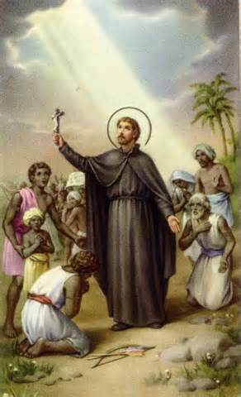

Pray for Us

Parish School of Religious Education
Parish Policies
Signature Sheet

I have received, read and discussed the Parish Policies with my child/children and we agree to adhere to the policies as they have been set forth.

_________________________________________
Parent’s Signature

____________
Date

Please return to the CRE your child’s PSR teacher.

If you wish to become a Catechist (teacher) or volunteer, you must fill out the Catholic Diocese of Baton Rouge Application for Employees & Volunteers. Please note that by completing this application a background check will be performed. All Catechist and volunteers must take the prescribed child protection training. You must earn 80 hours to become certified. Credits are offered throughout the year by attending MAT classes and/or workshops available through the Diocese.

